Upload TSL files with TSL Editor using private key

Creating and uploading your TSL files

To create and upload your TSL files to your private zone, you need to use the TSL Editor providing the server name, the upload path, the username and the location of your private key. Your private key will be sent to you by encrypted email. You can download the TSL Editor (epsos-tsl-editor-3.0.0.jar) from https://bitbucket.org/openncp/tsl-utils/downloads/epsos-tsl-editor-3.0.0.jar

Prerequisite

To run TSL Editor, you need to have java 1.6 or higher installed on your machine
- Run a windows terminal.
- Go to folder where is stored the epsos-tsl-editor-3.0.0.jar file
- Type command: java –jar epsos-tsl-editor-3.0.0.jar
The window below opens
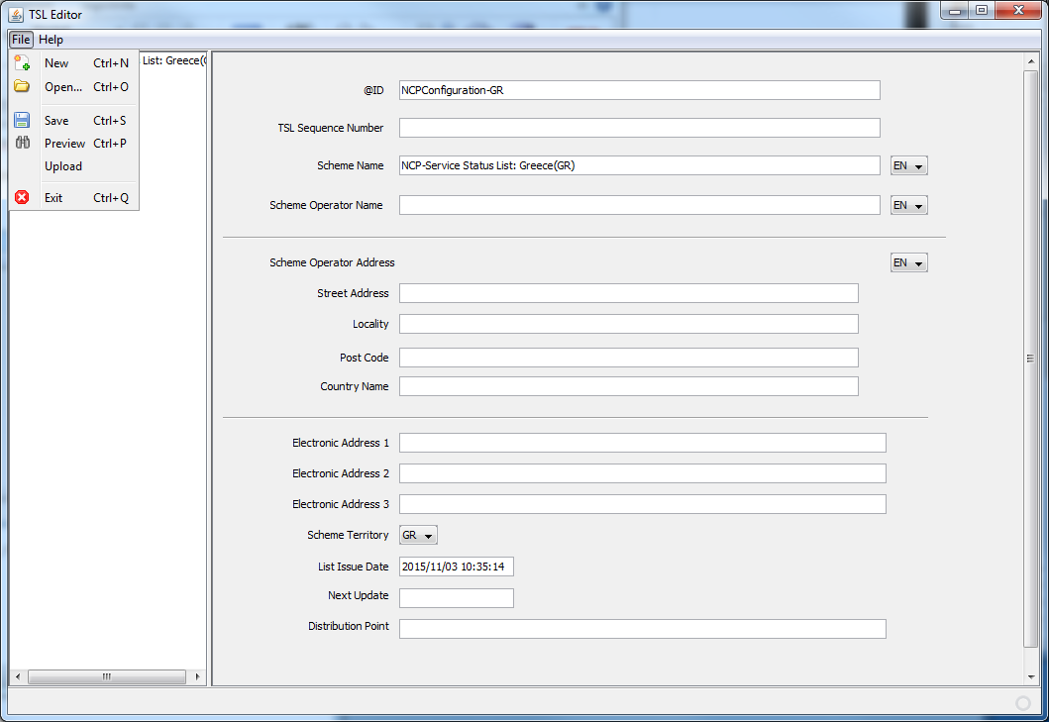
Create a new TSL file by clicking on File menu and the New submenu
After creating your TSL file, you need to upload it to your private zone by clicking to the Upload submenu. The window below appears. Fill the textfiled item as describe below.
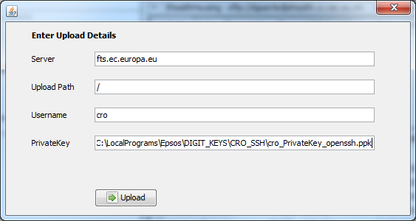
- Server: fts.ec.europa.eu
- Upload path: /
- Username: The username we sent to you
- Private key: The name of your private key with the full path.
You get this window if upload was successful.

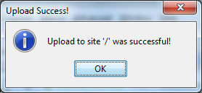

On the server runs a scripts that checks some parts and if all checks are OK the TSL file will be uploaded from the home-directory (private zone) into the webserver (public side) and the file is ready for download. During this process, an audit log is produced and saved.

