See also <http://ihewiki.wustl.edu/wiki/index.php/Syslog_Collector>

The DICOM schema both changes and extends the RFC-3881 schema, which until now has been used by the Syslog Collector to validate messages. IHE has decided that the DICOM schema will be used in preference to the RFC-3881 schema for ATNA syslog messages. Starting now, and for the 2014 Connectathons, the Syslog Collector will use both the RFC-3881 and DICOM schemas for validating syslog messages. At some time in the future, RFC-3881 validation will be dropped.

The analysis is based on the information from the Website mentioned above and using the XSD files from RFC-3881, DICOM and the modified DICOM – Schema used by IHE ATNA for validation.

CodedValue Type

- For purposes of generating audit messages conforming to the DICOM schema, the Encoded Value (EV) triplets in IHE audit message specifications are understood to represent EV("csd-code", "codeSystemName", and "originalText"), for example, the EventTypeCode EV("110122", "DCM", "Login") would be expressed as:
<EventTypeCode csd-code="110122" codeSystemName="DCM" originalText="Login" />

So the CodedValue Type is now:
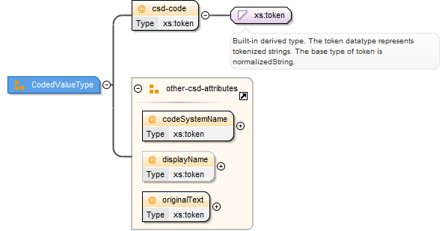
And was in RFC3881:
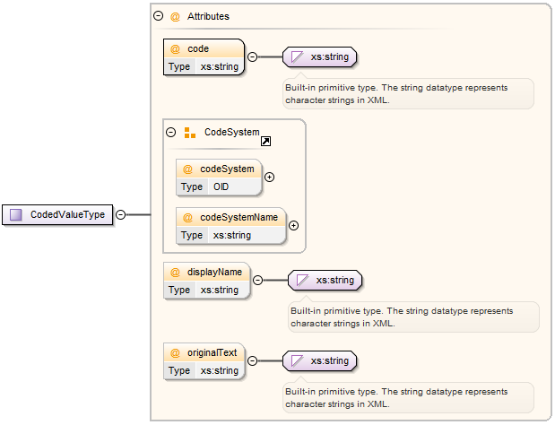

ACTION TO DO:
- I think a JAXB recreation has to be done using the dicom.xsd
  - Openncp-audit-manager/CodedValueType
  - Openatna/jaxb21/CodedValueType
- Change the name of the code attribute to csd-code
- The values which are now put into field displayName, should be written into the originalText field, as this field is now mandatory, whereas displayName is kept optional.
- I am not sure what has to be done with the OpenAtna, as it has the corresponding tables => Table codes

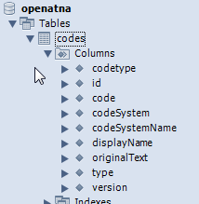

ParticipantObjectIdentification

ParticipantObjectName or ParticipantObjectQuery

The ParticipantObjectIdentification element is required by the DICOM schema to have at least one of the child elements ParticipantObjectName or ParticipantObjectQuery.

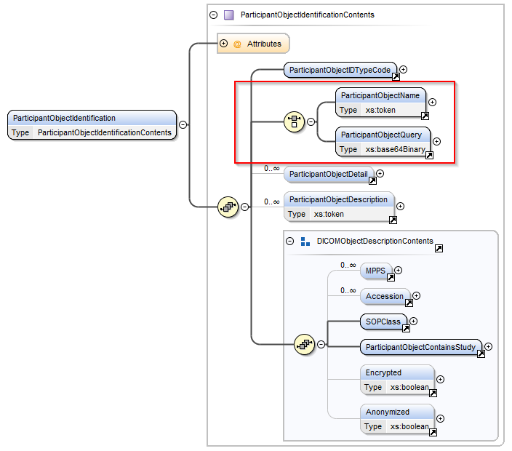
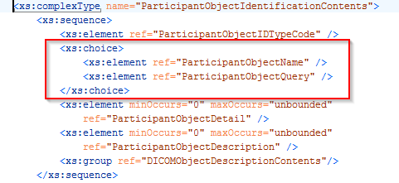
In the former RFC-3881 and in the ATNA modification of the DICOM format it is set to optional again.
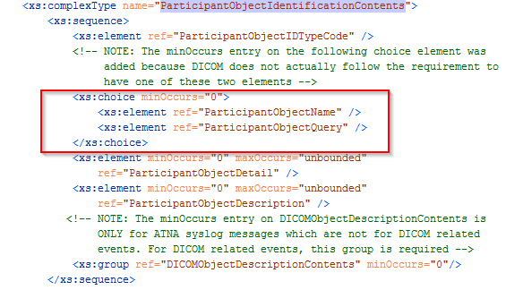
ACTION TO DO:
- NO CHANGE EXPECTED

ParticipantObjectID

The attribute ParticipantObjectID is required to appear in a ParticipantObjectIdentification element by the DICOM schema. This requirement will not be enforced unless the specifications of the particular audit message require it.

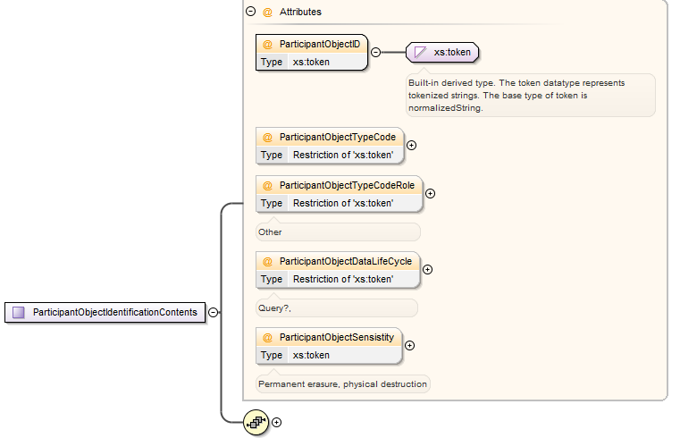
From dicom.xsd
<xs:attribute name="ParticipantObjectID" use="required" type="xs:token" />
From healthcare-security-audit.xsd (RFC 3881)
<xs:attribute name="ParticipantObjectID" type="xs:string" use="required"/>

When comparing, only the datatype has been changed, not the use.
ACTION TO DO:
- No change expected

DICOMObjectDescriptionContents

The ATNA modification of the DICOM schema sets the DICOMObjectDescriptionContents optional for the ParticipantObjectIdentification.
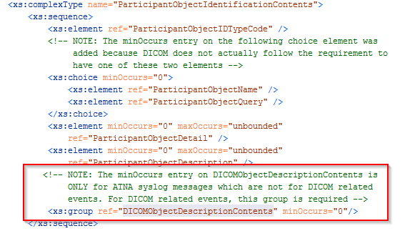
ACTION TO DO:
- No change expected

AuditSourceIdentification

The “code” element is now required. Both in the DICOM format and in the modified DICOM format for ATNA.
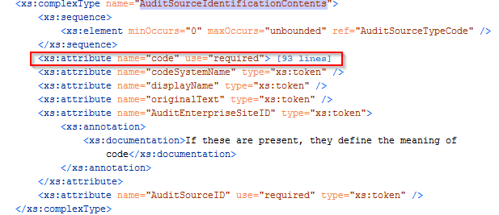
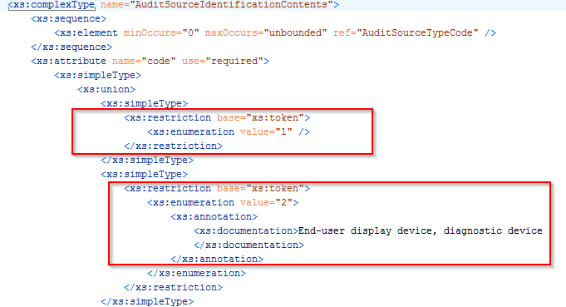
The DICOM format defines the codes from 1 to 9, but other codes can also be used when providing the codeSystemName and originalText.

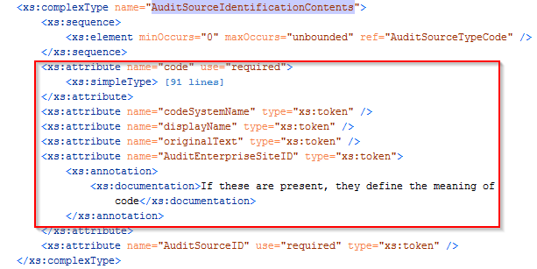
The ATNA modification of the DICOM schema removes the pre-defined codes from 1-9. In distinction to the CodedValueType, all the other elements are optional (incl. “originalText”).
ACTION TO DO:
- Audit source (see also 4.5.3.6 in epSOS WP3.4) needs to provide a code also, so the AuditSourceID and code.

ActiveParticipant

The element “UserIsRequestor” is now required.

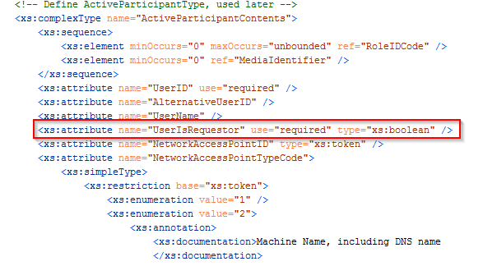

Following the specification in epSOS WP 3.4 D3.4.2 Chapter 4.5, all the usages of ActiveParticipant Identification are specified with UserIsRequestor as mandatory element.
ACTION TO DO:
- No change expected

